Prelude (or Postlude) StF 317 At the name of Jesus https://www.youtube.com/watch?v=K6AHbO29Ipg
1 At the name of Jesus  every knee shall bow,  every tongue confess him  King of Glory now.  'Tis the Father's pleasure  we should call him Lord,  who from the beginning  was the mighty Word.  2 Humbled for a season,  to receive a name  from the lips of sinners  unto whom he came,  faithfully he bore it  spotless to the last,  brought it back victorious  when from death he passed:  3 Bore it up triumphant  with its human light,  through all ranks of creatures  to the central height,  to the throne of Godhead,  to the Father's breast;  filled it with the glory  of that perfect rest. | 4 In your hearts enthrone him;  there let him subdue  all that is not holy,  all that is not true;  crown him as your captain  in temptation's hour:  let his will enfold you  in its light and power.  5 For this same Lord Jesus  shall return again,  with his Father's glory,  with his angel train;  all the wreaths of empire  meet upon his brow,  and our hearts confess him  King of Glory now.  Caroline Maria Noel (1817–1877)

Call to Worship
Our Lord has returned to his father so that the Church on earth may be filled with his presence and that he may remain with us always, to the end of the world.
HYMN StF 588 I come with joy https://www.youtube.com/watch?v=2MRvzCtbmIE

1 I come with joy, a child of God,
forgiven, loved, and free,
the life of Jesus to recall,
in love laid down for me.
2 I come with Christians far and near
to find, as all are fed,
the new community of love
in Christ's communion bread.
3 As Christ breaks bread, and bids us share,
each proud division ends.
The love that made us, makes us one,
and strangers now are friends.
4 The Spirit of the risen Christ,
unseen, but ever near,
is in such friendship better known,
alive among us here.
5 Together met, together bound
by all that God has done,
we'll go with joy, to give the world
the love that makes us one.
Brian Wren (b. 1936)

Junior Church Section
Prayer
Lord Jesus, when your time on earth came to an end, and you went to your Father, that is, our Father, in heaven, you told us that you would always be with us and would remain in our hearts through God’s Holy Spirit.
We pray, do not let us forget this. Help us to talk to you and to feel you talking to us. When we are uncertain about what to do, or lose our way, help us connect. We know that you are there, that you are the judge of everything that is right and wrong, so bless us with your presence inside us, so that we avoid going wrong as much as we can, and if we do go wrong, that you set us right. We know that you will forgive us our mistakes if we are determined to try our best.
Amen.
The Thwaite Debate
Thwaite considers his moniker. https://youtu.be/Ah-m69hcAkE
Junior Church introduction
Junior Church HYMN: 536 He’s got the whole world https://www.youtube.com/watch?v=HQgLsZXOa6U

1 He's got the whole world in his hand.
He's got the whole world in his hand.
He's got the whole wide world in his hand.
He's got the whole world in his hand.
2 He's got you and me, brother, in his hand.
He's got you and me, brother, in his hand.
He's got you and me, brother, in his hand.
He's got the whole world in his hand.
3 He's got you and me, sister, in his hand.
He's got you and me, sister, in his hand.
He's got you and me, sister, in his hand.
He's got the whole world in his hand.

4 He's got the little tiny baby in his hand.
He's got the little tiny baby in his hand.
He's got the little tiny baby in his hand.
He's got the whole world in his hand.
5 He's got everybody here in his hand.
He's got everybody here in his hand.
He's got everybody here in his hand.
He's got the whole world in his hand.
6 He's got the whole world in his hand.
He's got the whole world in his hand.
He's got the whole wide world in his hand.
He's got the whole world in his hand.
African-American traditional song

Junior Church blessing and departure for their own activities
Prayers of Approach and Confession
Lord, it is only you who can see into every situation and into all people. You are with us everywhere, in all events, good and bad. Wherever we go, you are with us too. You know our joys and fears, our hopes and our dreads. You know our thoughts, and nothing is hidden from you.
There is much in our thoughts that we are ashamed of. It is hard for us to get rid of all kinds of nasty elements, like anger, resentment, greed and meanness. We know these things are wrong and we are ashamed of them, but they persist. They pop up like weeds in a garden, and sometimes threaten to over-run everything else and choke it.
You know these things; you know them, as you know us. And you know us through and through; there is no avoiding that, nor should there be; for you have shown that you love us despite their our imperfections. You understand how mired we are in the worse side of our natures; but you commit to love us and be with us, and when we ask you to lead us, your hand is there for us to grasp.
Lord, let us grasp it now, knowing that in the shelter of your love, all shall be well.
And now we say together the prayers that Jesus himself taught us:
Our Father in heaven, hallowed be your name,
your kingdom come, your will be done,
on earth as in heaven.
Give us today our daily bread.
Forgive us our sins, as we forgive those who sin against us.
Lead us not into temptation but deliver us from evil.
For the kingdom, the power, and the glory are yours
now and for ever.
Amen.
READINGS
Luke 24:44-53
In the act of blessing, Jesus parted from them. This is the scene when Jesus went to heaven.
⁴⁴ He said to them, “This is what I told you while I was still with you: Everything must be fulfilled that is written about me in the Law of Moses, the Prophets and the Psalms.”
⁴⁵ Then he opened their minds so they could understand the Scriptures. ⁴⁶ He told them, “This is what is written: The Messiah will suffer and rise from the dead on the third day, ⁴⁷ and repentance for the forgiveness of sins will be preached in his name to all nations, beginning at Jerusalem. ⁴⁸ You are witnesses of these things. ⁴⁹ I am going to send you what my Father has promised; but stay in the city until you have been clothed with power from on high.”
⁵⁰ When he had led them out to the vicinity of Bethany, he lifted up his hands and blessed them. ⁵¹ While he was blessing them, he left them and was taken up into heaven. ⁵² Then they worshiped him and returned to Jerusalem with great joy. ⁵³ And they stayed continually at the temple, praising God.
John 17:10-19
They are still in the world…I am on my way
¹⁰ All I have is yours, and all you have is mine. And glory has come to me through them. ¹¹ I will remain in the world no longer, but they are still in the world, and I am coming to you. Holy Father, protect them by the power of your name, the name you gave me, so that they may be one as we are one. ¹² While I was with them, I protected them and kept them safe by that name you gave me. None has been lost except the one doomed to destruction so that Scripture would be fulfilled.
¹³ “I am coming to you now, but I say these things while I am still in the world, so that they may have the full measure of my joy within them. ¹⁴ I have given them your word and the world has hated them, for they are not of the world any more than I am of the world. ¹⁵ My prayer is not that you take them out of the world but that you protect them from the evil one. ¹⁶ They are not of the world, even as I am not of it. ¹⁷ Sanctify them by the truth; your word is truth. ¹⁸ As you sent me into the world, I have sent them into the world. ¹⁹ For them I sanctify myself, that they too may be truly sanctified.
Daniel 7:9-14
Daniel’s vision of the Ancient of Days and the Son of Man
⁹ “As I looked,
thrones were set in place,
and the Ancient of Days took his seat.
His clothing was as white as snow;
the hair of his head was white like wool.
His throne was flaming with fire,
and its wheels were all ablaze.
¹⁰ A river of fire was flowing,
coming out from before him.
Thousands upon thousands attended him;
ten thousand times ten thousand stood before him.
The court was seated,
and the books were opened.
¹¹ “Then I continued to watch because of the boastful words the horn was speaking. I kept looking until the beast was slain and its body destroyed and thrown into the blazing fire. ¹² (The other beasts had been stripped of their authority, but were allowed to live for a period of time.)
¹³ “In my vision at night I looked, and there before me was one like a son of man, coming with the clouds of heaven. He approached the Ancient of Days and was led into his presence. ¹⁴ He was given authority, glory and sovereign power; all nations and peoples of every language worshipped him. His dominion is an everlasting dominion that will not pass away, and his kingdom is one that will never be destroyed.”
HYMN StF 673 Will you come and follow me https://www.youtube.com/watch?v=Q_KR9f-7a7o
1 Will you come and follow me  if I but call your name?  Will you go where you don't know  and never be the same?  Will you let my love be shown,  will you let my name be known,  will you let my life be grown  in you and you in me?  2 Will you leave yourself behind  if I but call your name?  Will you care for cruel and kind  and never be the same?  Will you risk the hostile stare  should your life attract or scare?  Will you let me answer prayer  in you and you in me?  3 Will you let the blinded see  if I but call your name?  Will you set the prisoners free  and never be the same?  Will you kiss the leper clean,  and do such as this unseen,  and admit to what I mean  in you and you in me? | 4 Will you love the ‘you' you hide  if I but call your name?  Will you quell the fear inside  and never be the same?  Will you use the faith you've found  to reshape the world around,  through my sight and touch and sound  in you and you in me?  5 Lord, your summons echoes true  when you but call my name.  Let me turn and follow you  and never be the same.  In your company I'll go  where your love and footsteps show.  Thus I'll move and live and grow  in you and you in me.  John L. Bell (b. 1949) and Graham Maule (b. 1958)
Sermon
Today is a joyous day, the Sunday when we celebrate the ascension. But some people find the visual image of Jesus’s departure in the direction of heaven troubling and are uncomfortable with an account that describes the cosmos in a way that cannot be reconciled with our scientific understandings. Heaven, most people will now agree, is not simply a place just beyond the clouds. For that reason, I have avoided the usual reading from Acts 1, which describe the ascent, and concentrated on the other set readings for this day, from Luke, John and Daniel – which don’t. Luke, as you have heard, says that Jesus departed whilst delivering a blessing. John is concerned with the relationship between the world, God and himself. But it is particularly Daniel, writing about a hundred and fifty years before Jesus’s time on earth, who gives us a close insight into Jesus’s own understanding of his position – who and what he was, and the authority given to him by God.
Daniel is a prophet whose vision is full of action and drama. He dreams of situations which grab your attention and stun you with their violence and horror. You will perhaps remember the episode in the lions’ den and the prophecies against and reduction of the hugely powerful king Nebuchadnezzar II to a wild beast.
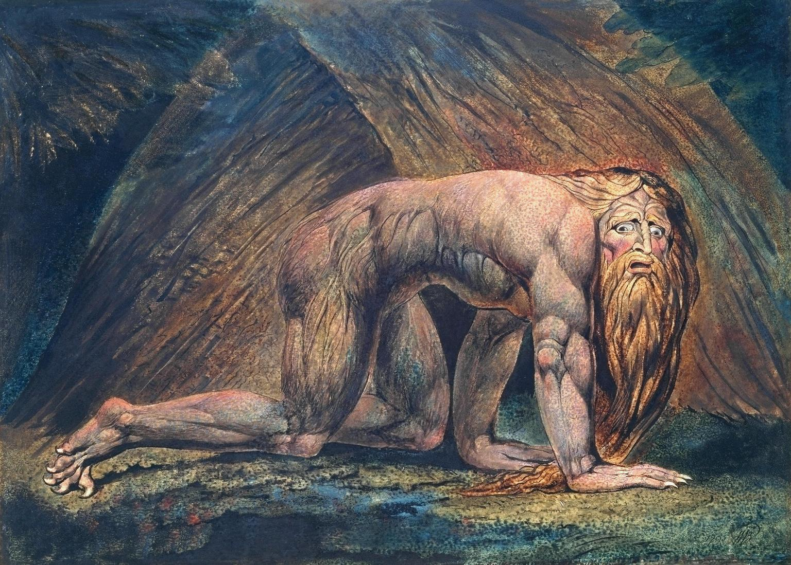
Today, in our reading, we heard not of the situation in Babylon, but of that in heaven. God is portrayed as a magnificent ancient being who exceeds emperors in power. No creature has any sovereignty of their own in his presence. He pre-dates everyone. He is eternal, but everything else is temporary. His environment is fire which protects and purifies, but also makes him unapproachable. The scene is full of symbolism which would have been understood by an ancient Israelite, but it only partly accessible to us in the modern age, but the atmosphere of dread shines through.
Then – and for a Christian, this is the really significant bit – one “like the Son of Man” approaches, accompanied by the clouds of heaven. A human in appearance, with heavenly trappings, he was presented to the Ancient and granted power over all people and all nations, unlimited in time, complete and not subject to any challenge in scope or in time. He stands, as a figure of power, in contrast to the wild beasts also present, who are stripped of authority and have a limited lease of life.
Well, the reason for the inclusion of this passage on this day, the feast of the Ascension, is that it closely mirrors what is said in the Gospels and in Acts about Jesus’s status in relation to God and his Kingdom. Jesus is related to eternal God, whereas the beasts of the world are much more limited. Temporary existence and destruction that comes soon are their lot.
‘Son of Man’ is a phrase which Jesus frequently used to refer to himself. There is no ready translation of it. People have translated it as ‘himself’, a sort of way of Jesus referring to himself in the third person. Others have stressed how it labels Jesus as human in appearance, and present in the world through the normal human process of birth, but of God. The human kingdom of Israel, which is the point where God’s kingdom touches earth, is the arena in which the Son of Man does his work, aimed at Israel’s deliverance from the forces which would drag it away from God and towards the savage destruction which the beasts in Daniel’s vision represent.
What Daniel’s vision says – and the reason it is set for today – is that Jesus used his double nature, human and divine, to intervene in human development during his life on earth, and after the ascension, used it, and uses it, permanently with God’s authority to govern all people. Jesus, Son of Man, is the only one able to fulfil this brief; others, who are prophets, can do it only partially, because they are earth-bound. Jesus is no longer on earth only; he cannot be confined to Galilee or to Israel; he is everywhere, unlimited in his scope.
It's all there in Daniel; the very words are used:
[the Son of Man] “…was given authority, glory and sovereign power; all nations and peoples of every language worshipped him. His dominion is an everlasting dominion that will not pass away, and his kingdom is one that will never be destroyed.”
That is the meaning of the Ascension: that Jesus is installed in God’s system for the world, in charge of all people, everywhere, with unlimited authority not bounded by time.
The people who convicted and crucified Jesus believed that they were snuffing him out, swatting him as one might swat a troublesome insect. They are equivalent to the beasts in Daniel’s vision. That prophecy indicates that no such measure could succeed, because although they could kill his human body, they could not kill other aspects of his existence. The Son of Man looks human, but the power of God within him takes him up and beyond the power of mankind – of the world and its beasts - to destroy.

HYMN StF 348 He is Lord https://www.youtube.com/watch?v=uCdT2VTmhVQ

1 He is Lord, he is Lord;
he is risen from the dead, and he is Lord;
every knee shall bow, every tongue confess
that Jesus Christ is Lord.
2 He is King, he is King;
he will draw all nations to him, he is King;
and the time shall be when the world shall sing
that Jesus Christ is King.
3 He is love, he is love;
he has shown us by his life that he is love;
all his people sing with one voice of joy
that Jesus Christ is love.
4 He is life, he is life;
he has died to set us free and he is life;
and he calls us all to live evermore,
for Jesus Christ is life.
Anonymous

Prayers of Intercession
We bring before you, O Lord, the troubles and perils of peoples and of nations, the sighing of prisoners and captives, the sorrows of the bereaved, the necessities of strangers, the helplessness of the weak, the despondency of the weary, the failing powers of the aged. O Lord, draw near to each; for the sake of Jesus Christ Our Lord.
O God our father, in the name of him who gave bread to the hungry we remember all who, through our, yes our, human ignorance, selfishness and sin, are condemned to live in want; and we pray that all endeavours for the overcoming of world poverty and hunger may be so prospered that there may be found food sufficient for all.
O God, the refuge of the poor, the strength of those who toil and the comforter of all who sorrow, we commend to your mercy the unfortunate and needy in whatever land they may be. You alone know the number and extent of their suffering and trials. Look down, Father of mercies, at those unhappy nations, towns, villages and families suffering from war and violence, from hunger and disease, and other trials. Spare them, O Lord, for it is a time for mercy. Take us away from those who rule like wild beasts.
And today, we pray particularly for Gaza and Israel, where violence has flared up and threatens to overwhelm the region.
And bless us, too, though we may have a lesser need. Bless all here in Woodley, and bless those known to us who stand in need of your help today.
<specific intercessions from congregation>
Open and touch our hearts that we may see and do the things that belong to our peace. Strengthen us in our work; give us wisdom, perseverance, faith and zeal, and in your own time prosper the issue; through Jesus Christ our Lord.

Amen

HYMN StF 486 Who would true valour see https://www.youtube.com/watch?v=8F_zasQ1-As

1 Who would true valour see,
let him come hither;
one here will constant be,
come wind, come weather;
there's no discouragement
shall make him once relent
his first avowed intent
to be a pilgrim.
2 Whoso beset him round
with dismal stories
do but themselves confound;
his strength the more is.
No lion can him fright;
he'll with a giant fight;
but he will have a right
to be a pilgrim.
3 Hobgoblin nor foul fiend
can daunt his spirit;
he knows he at the end
shall life inherit.
Then fancies fly away,
he'll fear not what men say;
he'll labour night and day
to be a pilgrim.
John Bunyan (1628–1688)

Blessing
The peace of God be with you,
the peace of Christ be with you,
and with your families,
for an hour,
for today,
for this week,
for ever.
Amen

____________________________________________________________
CCLI number 482115

The picture is by William Blake

